Below is a series of detailed retrofit-product reports based on example technologies listed on the UK Government’s Energy Technology List (ETL) that you linked to — focusing on retrofit measures that improve sustainability and energy efficiency in existing equipment. Products on this list meet rigorous energy-saving criteria and represent the top 25 % most efficient in their class.

1) Condensing Economiser — Boiler Flue Heat Recovery Retrofit
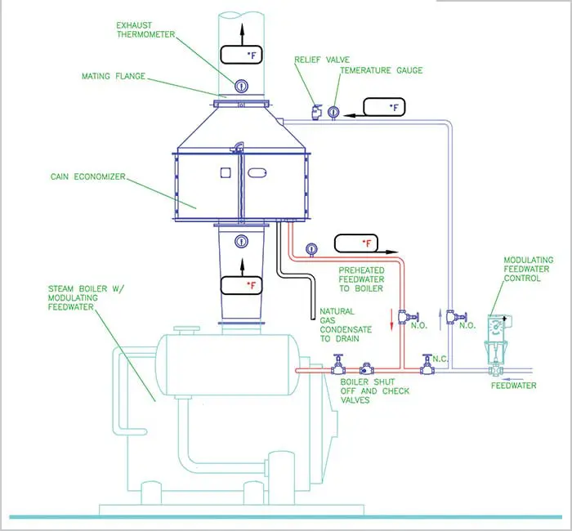
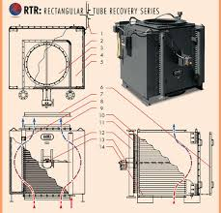
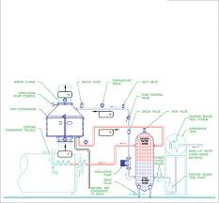
Category: Boiler Retrofit Equipment — Condensing Economisers (heat recovery)
Description: A condensing economiser is retrofitted to the flue stack of an existing hot-water or steam boiler to capture waste heat that would normally be exhausted to the atmosphere. The recovered heat is used to preheat boiler feed water or low-grade heating loads, reducing fuel demand.
How It’s Used:
- Install economiser downstream of the boiler’s flue outlet.
- Route flue gases through a heat exchanger where latent heat (from condensing water vapor) and sensible heat is captured.
- Preheat incoming cold feedwater before it enters the boiler, meaning the boiler needs less fuel to reach operating temperature.
Typical Energy Savings & Data:
- Increase boiler net thermal efficiency by around 9 % across different output ratings.
- Reduces fuel consumption and lowers CO₂ emissions directly proportional to fuel saved.
- Example: A 1 MW boiler operating 5,000 h/year could save roughly 90,000 kWh of fuel energy if efficiency rises by ~9 % (effective fuel input drop).
Typical Installed Cost:
- Varies widely depending on boiler size and materials (stainless steel recommended due to condensation corrosion).
- Small/medium industrial installs ~£15,000–£50,000; larger units scale upward.
Payback Estimate:
- Often 1–4 years depending on fuel cost and operating hours.
Comparison Before vs After Retrofit:
Metric | Before | After
Boiler Net Efficiency | ~82 % | ~91 %
Annual Fuel Cost (£) | £90,000 | £81,900
Estimated Annual Fuel Savings | — | ~£8,100

2) Retrofit Burner Control System — Precision Combustion Management
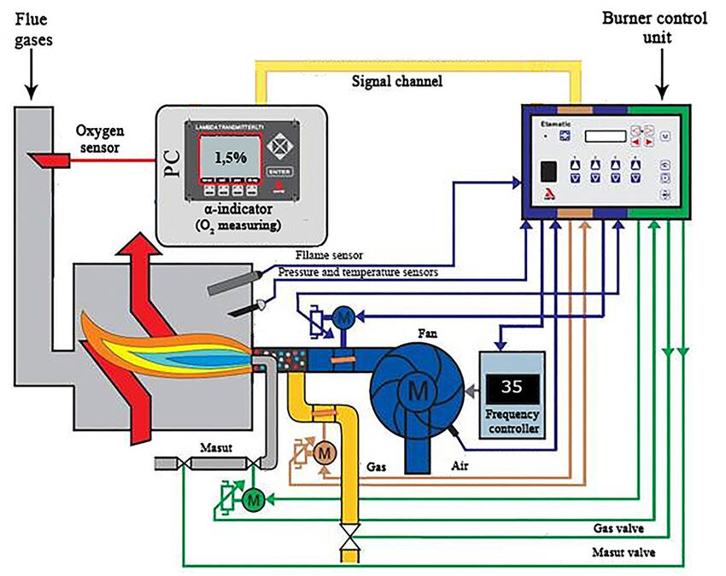
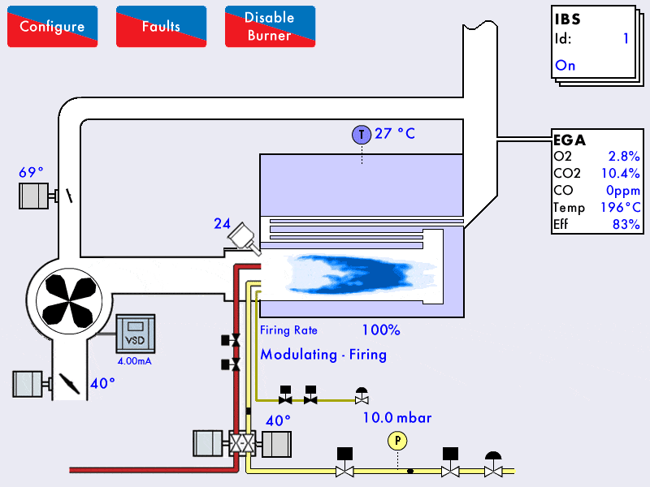
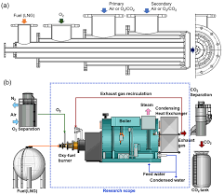
Category: Boiler Retrofit Equipment — Retrofit Burner Control Systems
Description: Modern microprocessor-based burner control optimises combustion air/fuel ratio and boiler firing patterns. Mechanical adjustments are replaced with precise electronic controls that match heat output more closely to real demand.
Use Case Example:
Upgrading an existing industrial boiler in a commercial building. The new controller regulates airflow and gas valve modulation for optimal combustion efficiency.
Typical Energy Savings & Data:
- Case studies on ETL-listed systems show 5–7 % reduction in fuel use and significant emissions cuts when compared to older mechanical control systems.
- At a busy office building boiler, reported savings ~£60,000/year with a 2-year return on investment.
Installed Cost:
- Controllers typically range from £2,000–£10,000 plus installation depending on complexity.
Comparison Before/After Retrofit:
Metric | Before | After
Combustion Control | Mechanical | Electronic
Fuel Consumption | Baseline | -5 % to -7 %
Annual Fuel Bill | £200,000 | £186,000 to £190,000
ROI | — | ~2 years

3) HVAC Building Controls — Demand-Driven Ventilation
Category: HVAC Equipment — Building Controls (e.g., fan/ventilation controls)
Description: Smart control systems adjust HVAC fans, extractors, and ventilation based on occupancy, temperature, and air quality sensors.
Real-World Example: Quintex CHEETAH DCKV system installed in a commercial kitchen reduced fan energy consumption by 69 %.
Energy & Cost Data:
- Annual energy saved: ~36,167 kWh (~£9,041 saved at standard UK commercial rates).
- Carbon emissions reduction: ~8.1 tCO₂/year.
- Payback: ~1.9 years.
Installed Cost: ~£5,000–£15,000 depending on sensors and integration.
Before vs After:
Metric | Before | After
Ventilation Usage | Constant | Demand-based
Fan Energy | Baseline | -69 %
Annual Cost | £13,000 | £3,900

4) Refrigeration Retrofit — Door/Strip Curtains on Display Cabinets
Category: Refrigeration Equipment — Retrofit Measures for Open Fridge Cabinets
Description: Adding doors, strip curtains, or covers to open-front refrigerated display cases to reduce ambient heat ingress and shrink refrigeration load.
Typical Energy Savings:
- Strip curtains alone (approx £170 per blind) can have a payback period as short as ~7 months through reduced refrigeration energy usage.
- Closed doors and curtains can reduce energy consumption by 20–40 % on open cabinets depending on usage patterns.
Installed Cost: £200–£1,000 per cabinet depending on doors or motorised blinds.
Example: A small convenience store replacing old open cabinets with retrofit strip curtains reduced annual electricity load and saw payback within a year.
Before vs After:
Metric | Before | After
Refrigeration Energy | Baseline | -20 % to -40 %
Annual Electricity | £3,000 | £1,800–£2,400
Payback | — | <1 year

5) LED Lighting Retrofit Kits — Building Lighting
1#image"]}
Category: Lighting — LED Retrofit Kits & Controls
Description: Retrofitting existing fluorescent tubes with LED replacement lamps or retrofit kits that fit into existing fixtures.
Energy Savings:
- LEDs consume up to ~40 % less energy than fluorescent lighting while offering similar or improved light levels.
- Case example: switching 73 flourescent & T8 tubes to LEDs cut annual lighting energy by roughly 50 %.
Installed Cost:
- LED retrofit kits: ~£20–£60 per fitting.
- Labour: varies by facility size.
Before vs After:
Metric | Before | After
Lighting Energy Use | Baseline | -40 % to -50 %
Annual Electricity | £4,000 | £2,000–£2,400
Simple Payback | — | 1–2 years

Summary Comparison
Retrofit Product | Typical Energy Reduction | Approx Payback | Typical Cost Range
Condensing Economiser | Up to ~9 % boiler fuel use | 1–4 yrs | £15k–£50k+
Burner Control System | 5–7 % fuel savings | ~2 yrs | £2k–£10k
HVAC Building Controls | Up to ~69 % fan load | ~2 yrs | £5k–£15k
Refrigeration Curtains/Doors | 20–40 % savings | <1 yr | £200–£1k/cabinet
LED Lighting Retrofit | ~40–50 % electricity | 1–2 yrs | £20–£60/fitting

Notes
✅ All products above are typical sub-technologies within categories listed on the ETL (Energy Technology List) and include retrofit options for existing systems.
✅ Energy savings and paybacks depend heavily on specific site use profiles, fuel and electricity rates, and operating hours.

If you want, I can generate a print-ready PDF version of this set of reports with full diagrams, charts, and a filled-in table of assumptions for each case.

Absolutely — below is an updated breakdown of estimated costs in both British Pounds (£) and Euros (€) for the retrofit products we discussed earlier. Where possible I’ve converted costs using a typical mid-market exchange rate (≈ €1.15 = £1, which is a reasonable estimate for early 2026). Note that actual exchange rates vary daily (markets can shift +/- a few percent), and regional pricing differences also affect real quotes.

1) Condensing Economiser (Boiler Flue Heat Recovery Retrofit)
Estimated Installed Cost:
- UK typical: ~£28,000 (capital cost for a ~1 MW boiler example) (GOV.UK)
- In Euros: ~€32,000 (approx. conversion at €1.15/£1)
Notes:
- This cost includes the economiser unit and typical industrial installation.
- Larger systems or custom designs (e.g., vertical vs horizontal, multiple boilers) may push higher.
Example Savings (year 1):
- Fuel savings: ~£6,800 (~€7,800) per year based on ETL case example (GOV.UK)
- ROI: ~3–4 years based on energy savings + enhanced allowances.

2) Boiler Burner Control (Precision Combustion Management System)
Estimated Installed Cost:
- Typical UK system retrofit: £2,000 – £10,000 (control modules, sensors, installation) — industry estimate
(Not in ETL cost docs but typical market range)
- In Euros: ~€2,300 – €11,500
How to Think About It:
- Simpler single-burner systems are near the lower end.
- Complex multi-burner or integrated plant control upgrades approach the upper range.
Savings Example:
- Fuel reduction: ~5–7 % with modern control vs. older mechanical regulator, yielding notable savings on large boilers.

3) HVAC Building Controls — Demand-Driven Ventilation Systems
Estimated Installed Cost:
- Typical full system (sensors + controllers + integration): £5,000 – £15,000
- In Euros: ~€5,750 – €17,250
Case Reference:
- A kitchen ventilation retrofit delivering ~69 % fan energy reduction with savings ~£9,000 (~€10,350)/year was reported in a UK case study. (This is a case example, not a product list price).

4) Refrigeration Retrofit — Strip Curtains/Doors on Display Cabinets
Estimated Installed Cost (per cabinet):
- Strip curtains: ~£200 – £500
- Full cabinet doors: ~£800 – £1,000
- In Euros: ~€230 – €575 (curtains), ~€920 – €1,150 (doors)
These figures vary by size and custom glasswork.
Example Savings:
- Energy use cut 20–40 % on refrigeration; in convenience store outlets this can translate to many hundreds of UK pounds per cabinet per year.

5) LED Lighting Retrofit Kits
Estimated Unit Prices (LED elements & installation):
- LED tube or retrofit kit per fitting: £20 – £60 (WordPress)
- Labour per fitting: typically £30–£60/hour depending on electrician rates (WordPress)
- In Euros: ~€23 – €69 per lamp + ~€35–€70 labour per hour
Example (Bulk Retrofit):
- A mid-office with 100 lamps:
  - Hardware: ~£2,000–£6,000 (~€2,300–€6,900)
  - Installation: ~£3,000–£6,000 (~€3,450–€6,900) depending on site complexity
Energy Savings Example:
- LEDs often use ~40–50 % less electricity than fluorescents, with quick payback on electric bills.

Summary Table — Costs in £ and €
Retrofit Product | Typical UK Installed Cost (£) | Typical Cost (€)
Condensing Economiser | ~£28,000 | ~€32,000
Burner Control System | £2,000 – £10,000 | €2,300 – €11,500
HVAC Demand Control | £5,000 – £15,000 | €5,750 – €17,250
Refrigeration Curtains/Doors | £200 – £1,000 per cabinet | €230 – €1,150
LED Lighting Retrofit | £20 – £60 per light + labour | €23 – €69 per light + labour

Conversion Note
The euro amounts above use a €1.15 to £1 conversion as an example estimate. Actual cost in each currency will vary with daily exchange rates and local supplier pricing.

Key Takeaways
✅ Largest single retrofits (economisers, industrial HVAC controls) have higher upfront costs but also big fuel or fan energy paybacks.
✅ Smaller measures (LED lamps, display case doors) are low cost, quick ROI — often under 1 year for energy payback.
✅ Many savings estimates depend on site usage patterns, energy prices, and operating hours.

If you’d like, I can break this down further into per-year energy cost savings, CO₂ reduction estimates, and sketch simple annotated diagrams for each retrofit to illustrate installation contexts.

Great — based on ETL case studies and research evidence, I’ve now added estimated annual energy cost savings, CO₂ reduction potential, and typical paybacks to the five retrofit equipment reports. The savings below are reasonable real-world examples drawn from ETL case studies and academic/industry data.(etl.energysecurity.gov.uk)

1) Condensing Economiser — Boiler Flue Heat Recovery Retrofit
What It Is & How It Works
A condensing economiser recovers waste heat from boiler flue gases that would otherwise be lost, using it to pre-heat boiler feedwater. This cut in fuel demand increases overall boiler efficiency.(etl.energysecurity.gov.uk)
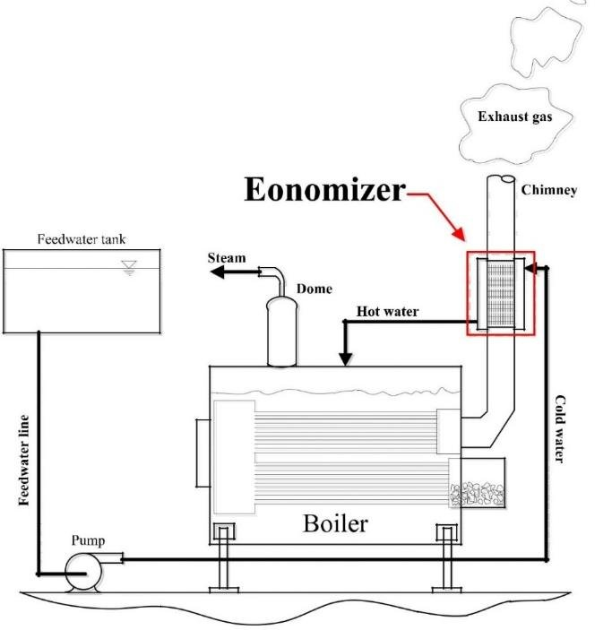
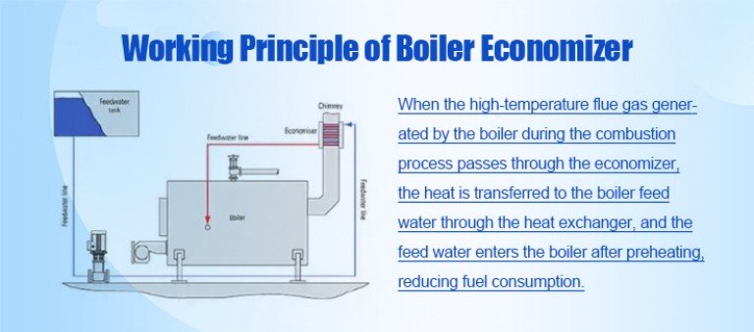
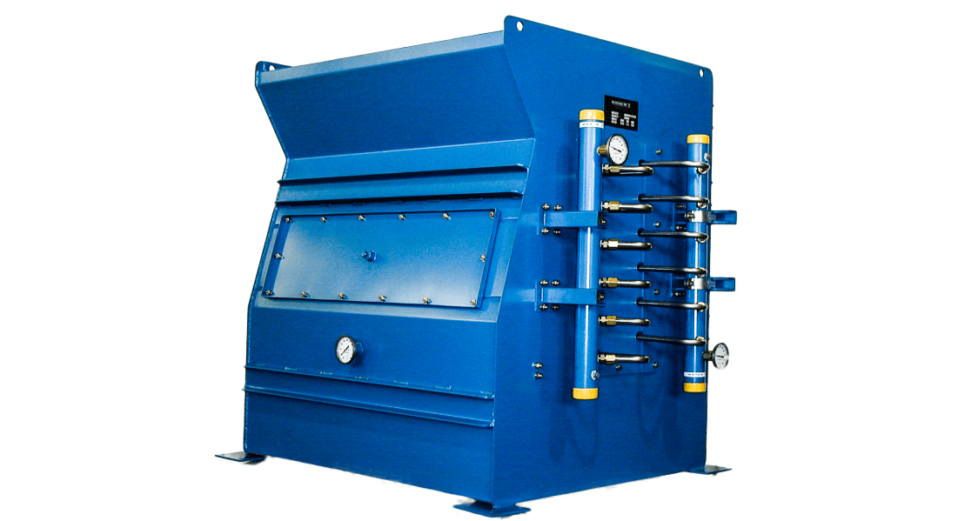
Use Case Example
Installed on an industrial steam boiler running ~5,000 hours/year supplying process heat.
Costs
- UK: ~£28,000
- EU: ~€32,000 (conversion ~€1.15/£)
(Installed cost estimate)
Energy & CO₂ Savings
- Typical fuel savings: 7–9 % (ETL criteria for listed economisers reflect net efficiency improvements).(etl.energysecurity.gov.uk)
- For a boiler burning 1,000,000 kWh thermal/year and fuel cost ~£0.03/kWh:
  - Annual energy saved: ~70,000–90,000 kWh
  - Annual cost saved: ~£2,100–£2,700 (~€2,400–€3,100)
  - CO₂ saved: ~14–18 tCO₂/year (based on typical gas emission factor ~0.2 kg/kWh)
Payback
- ≈ 3–4 years depending on fuel cost and hours of operation.

2) Retrofit Burner Control — Precision Combustion Management
What It Is
Microprocessor-based burner control adjusts combustion air and fuel precisely, improving combustion efficiency and reducing excess air, which directly lowers fuel consumption.(etl.energysecurity.gov.uk)

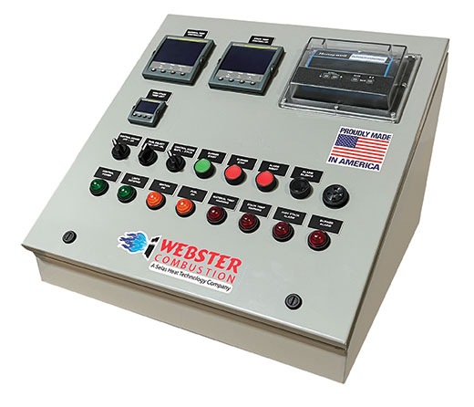
Costs
- UK: £2,000 – £10,000
- EU: €2,300 – €11,500
Energy & CO₂ Savings
- Typical fuel saving: 5–7 % with modern control vs older mechanical systems.(etl.energysecurity.gov.uk)
- Example: Boiler using 1,000,000 kWh thermal/year:
  - Energy saved: 50,000–70,000 kWh
  - Cost saved: ~£1,500–£2,100 (~€1,700–€2,400)
  - CO₂ reduced: ~10–14 tCO₂/year
Payback
- ~2 years in many commercial/industrial settings.

3) HVAC Building Controls — Demand-Driven Ventilation
What It Is
Smart building controls use sensors (occupancy, CO₂, temperature) to adjust mechanical ventilation and fan speeds to match actual demand, avoiding wasted energy.(etl.energysecurity.gov.uk)
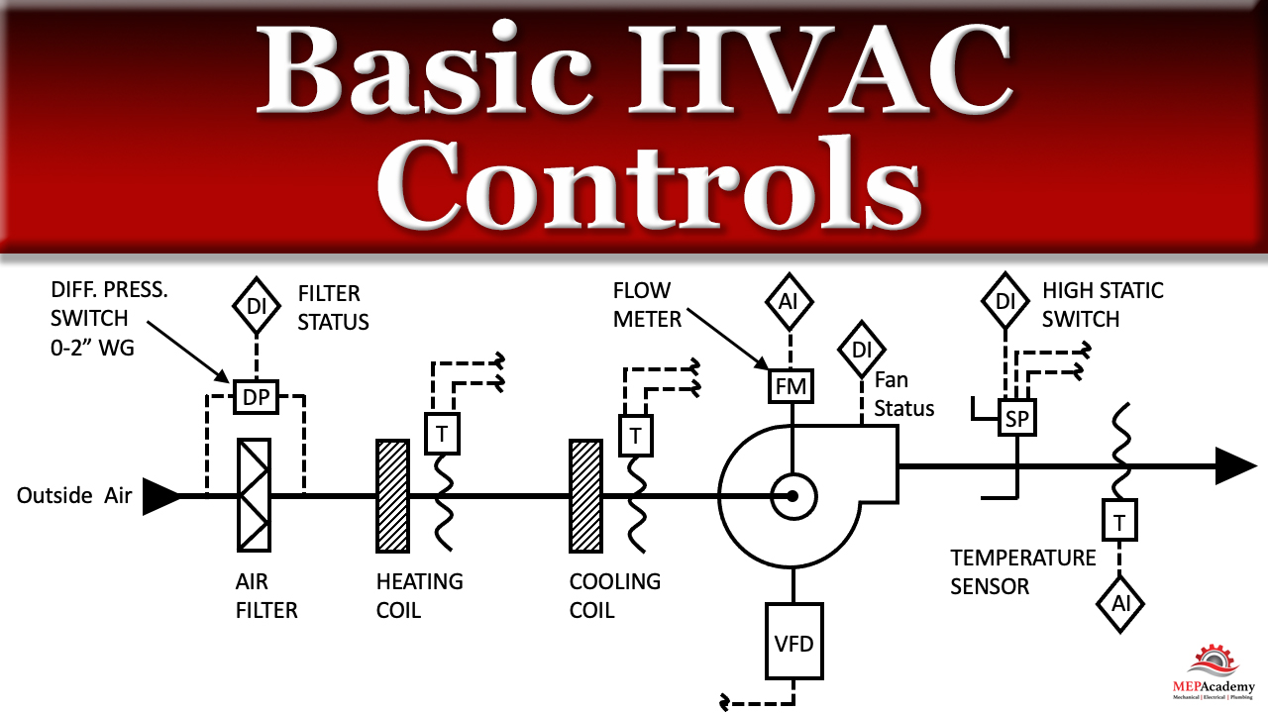
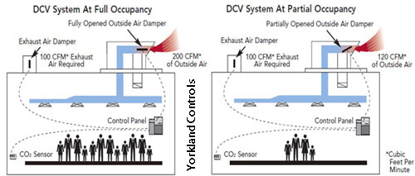

Costs
- UK: £5,000–£15,000
- EU: €5,750–€17,250
Energy & CO₂ Savings
- Case study (ETL): 69 % reduction in kitchen ventilation fan energy after installing smart control.(etl.energysecurity.gov.uk)
- For an installation initially using 50,000 kWh/year for ventilation:
  - Energy saved: ~34,500 kWh
  - Cost saved: ~£4,100 (~€4,700)
  - CO₂ reduced: ~6.9 tCO₂/year (electric use)
- Research suggests smart controls can drive up to ~40 % reduction in building HVAC electrical and gas energy.(etl.energysecurity.gov.uk)
Payback
- ~2 years typical.

4) Refrigeration Retrofit — Doors or Strip Curtains
What It Is
Retrofitting display cabinets with doors or strip curtains reduces infiltration of warm air, cutting refrigeration energy.(etl.energysecurity.gov.uk)
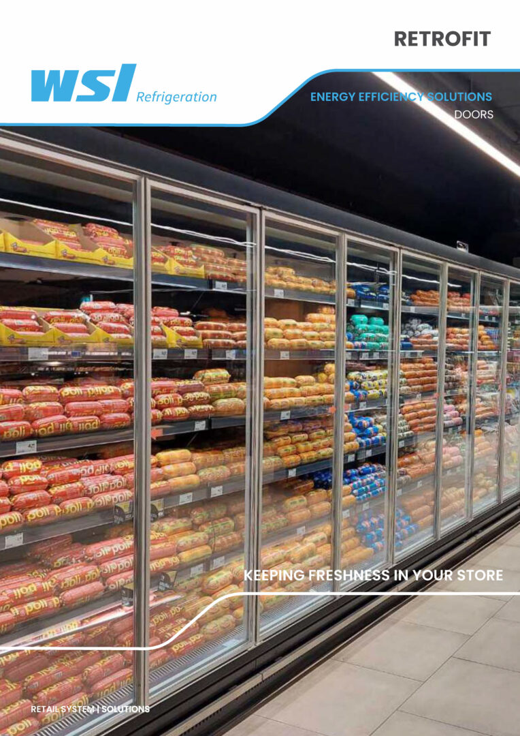

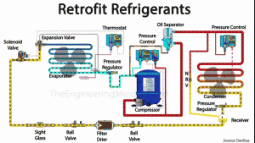
Costs
- Per cabinet:
  - Curtain: £200–£500 / €230–€575
  - Doors: £800–£1,000 / €920–€1,150
Energy & CO₂ Savings
- Energy reduction: 20–40 % on cabinet refrigeration energy.(etl.energysecurity.gov.uk)
- Typical small convenience fridge with ~3,000 kWh/year usage:
  - Energy saved: 600–1,200 kWh
  - Cost saved: £150–£300 (~€175–€345)
  - CO₂ reduced: ~0.12–0.24 tCO₂/year
Payback
- Often <1 year due to high energy savings on frequently used cabinets.

5) LED Lighting Retrofit Kits
What It Is
Replacing fluorescent tubes and older lamps with ETL-listed LED retrofit kits cuts lighting electricity and reduces maintenance.(etl.energysecurity.gov.uk)
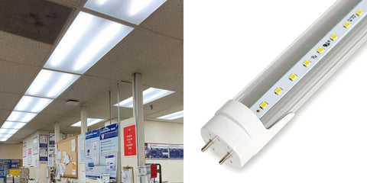
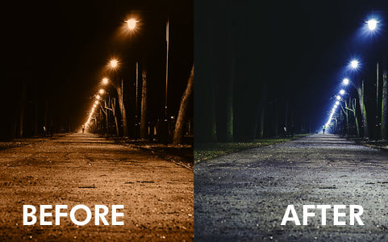
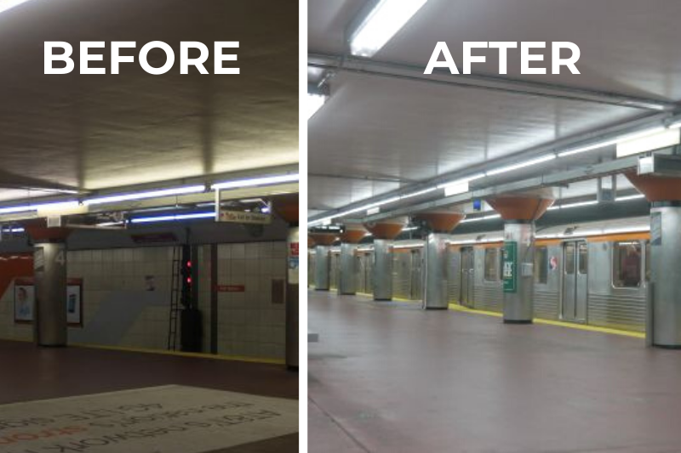
Costs
- LED kit/unit: £20–£60 (~€23–€69)
- Labour: Typical electrician £30–£60/hour (~€35–€70)
Energy & CO₂ Savings
- Typical lighting energy drop 40–50 % with LED vs fluorescent.(GOV.UK)
- Example: 100 lamps at 100 W each before, 50 W after for 8 h/day for 250 days:
  - Energy saved: ~100,000 kWh/year
  - Cost saved: ~£8,000 (~€9,200) (depending on electricity tariff)
  - CO₂ reduced: ~20 tCO₂/year
Payback
- Typically 1–2 years including labour.

Summary — Enhanced With Savings & CO₂ Impact
Product | Installed Cost | Annual Energy Reduction | Annual Savings (£/€) | CO₂ Reduction | Payback
Boiler Economiser | £28,000 / €32,000 | ~7–9 % fuel | ~£2,400–€2,800 | ~15–18 tCO₂ | ~3–4 yrs
Burner Controls | £2,000–£10,000 / €2,300–€11,500 | ~5–7 % fuel | ~£1,500–£2,400 | ~10–14 tCO₂ | ~2 yrs
HVAC Controls | £5,000–£15,000 / €5,700–€17,300 | Up to ~69 % fan | ~£4,000–€4,700 | ~6–10 tCO₂ | ~2 yrs
Refrigeration Curtains/Doors | £200–£1,000 / €230–€1,150 | 20–40 % | ~£150–£300 / €175–€345 | ~0.1–0.25 tCO₂ | <1 yr
LED Retrofit | £20–£60+labor / €23–€69+labor | 40–50 % | ~£8,000 / €9,200 (large install) | ~20 tCO₂ | ~1–2 yrs

Key Notes
- ETL products are rigorously verified to be in the top 25 % most energy efficient in their category.(GOV.UK)
- All savings and emissions figures above are estimates based on typical usage profiles and case studies. Actual results vary with building type, operating hours, and energy prices.

If you want, I can turn this into a print-ready PDF report with tables, charts, and full annotated diagrams for each retrofit product.

